Telluride Conference on Epithelial Physiology and Cell Biology
Organizers: John Cuppoletti, Tom Kleyman, My Helms, Pete Snyder
Telluride Elementary School (TSRC)
447 W Columbia Ave
____________________________________________________________________________

Monday July 27, 2015
12:30-1:30 PM Tom Kleyman
1:30-2:30 PM Oleh Pochynyuk
2:30-3:00 PM Break-refreshments
3:00-4:00 PM Vivek Bhalla
4:00-5:00 PM Heping Ma

Tuesday July 28, 2015
7:30 AM Breakfast at TSRC
8:00-9:00 AM John Cuppoletti
9:00-10:00 AM WenHui Wang
10:00-10:30 AM Break-refreshments
10:30--11:30 AM Doug Eaton
11:30-12:30 PM Carolyn Ecelbarger

6:00-7:15 PM Town talk
Telluride Conference Center in
Mountain Village
“What's in Your Extra Virgin Olive Oil?"
Selina Wang, Research Director, Olive Center, University of California (Davis)

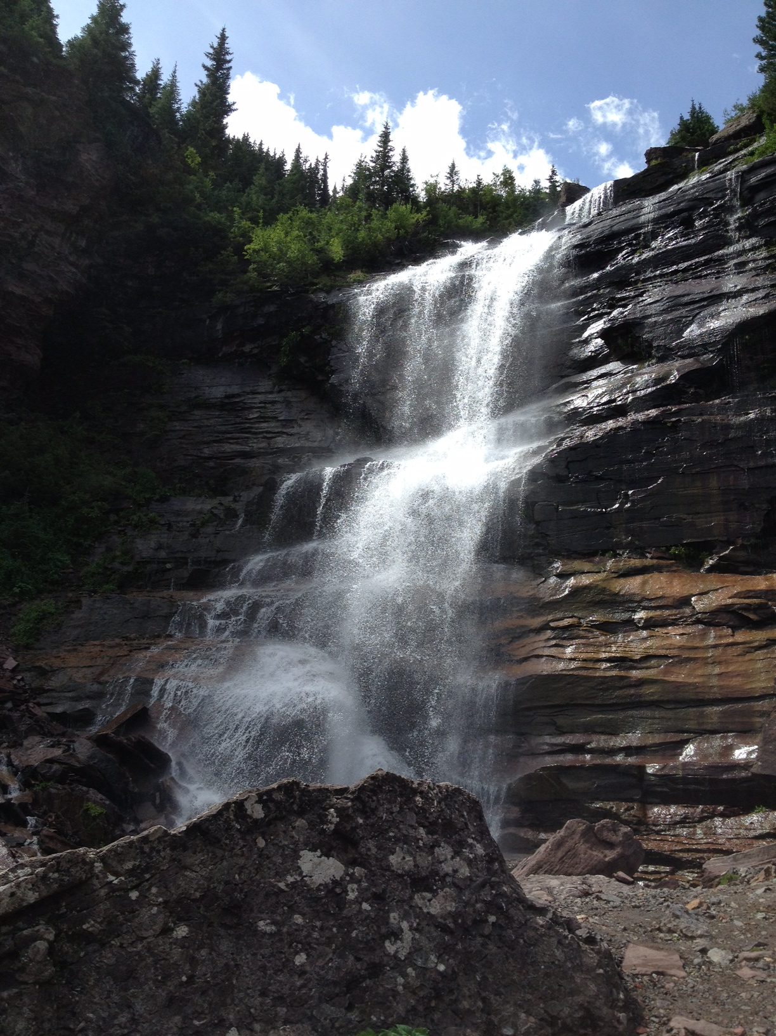

Wednesday July 29, 2015
7:30 AM Breakfast at TSRC
Group Science Hike

6:00 – 9:00 PM Picnic (tent outside
elementary school)

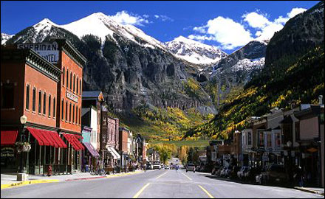

Thursday July 30, 2015
12:30-1:30 PM Michelle Gumz
1:30-2:30 PM Ossama Kashlan
2:30-3:00 PM Break-refreshments
3:00-4:00 PM Mykola Mamenko
4:00-5:00 PM Daria Ilatovskaya

Friday July 31, 2015
7:30 AM Breakfast at TSRC
8:00-9:00 AM Arohan Subramanya
9:00-10:00 AM Pete Snyder
10:00-11:00 AM
11:00-11:30 AM Wrap Up

